How do we price ski resort tickets or cut costs to accommodate the inclusion of new chair lift to increase earnings or decrease operating costs by 5% by the end of the next fiscal year?

Big Mountain Resort is in the data. Some AdultWeekend prices were missing and were dropped. The fastEight column only had null or zero values, so it was useless and got dropped. There are now 277 rows in the filtered data. The target feature are the AdultWeekday and AdultWeekend columns to determine an ideal price for Big Mountain Resort.

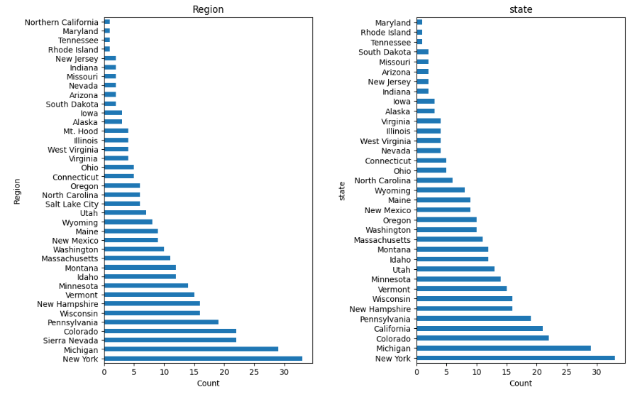

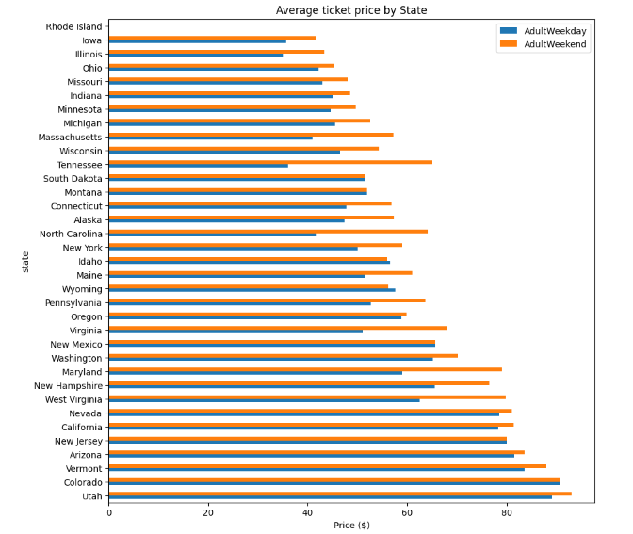

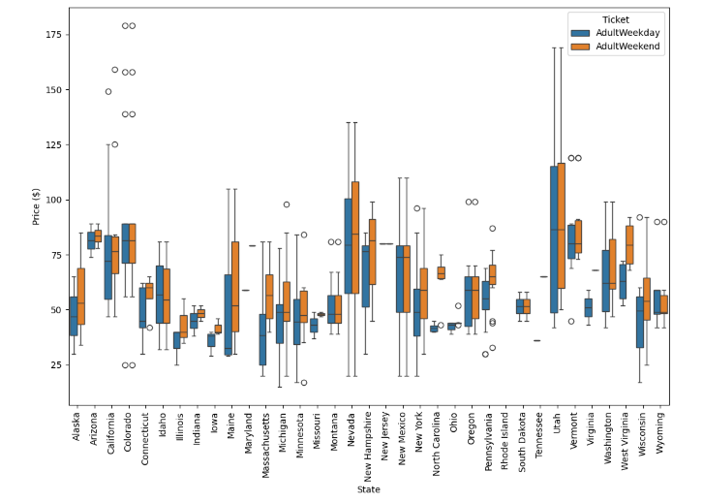

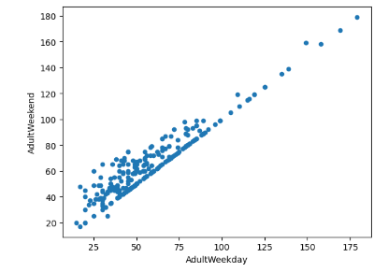

Fast quads have a significant impact on price if the resort covers a wide area. Visitors appear to value the amount of snow at a resort, which leads to higher costs and higher ticket prices. In addition, vertical drop and number of drops are also positively correlated with higher ticket prices. More densely populated areas tend to have more night skiing. Factors to be wary of is the relationship between the number of resorts in a state, the capita, and the density of the population.

In order to advise Big Mountain, the average price was taken as a baseline idea of performance.

The linear model's strategy was around the median and the suggested value for k was 8. It found that vertical_drop and Snow Making_ac columns were among the most important variables regarding ticket price.

The random forest model regressor also had a strategy around the median. The ideal amount of estimators is 69. The fastQuads, Runs, Snow Making_ac, and vertical_drop columns sequentially were among the best 4 feature importances sequentially.

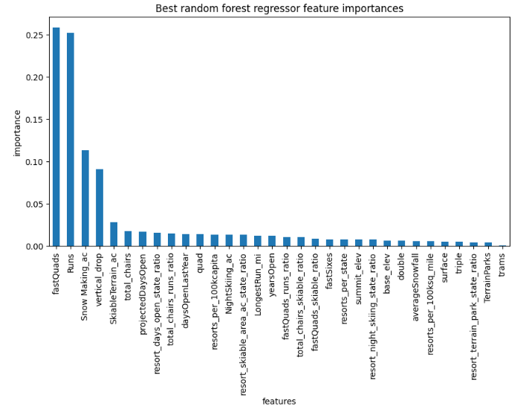

The random forest regression model had a MAE mean of 9.6 and MAE STD of 1.3. The linear model had one of 10.4 and 1.6 respectively. The cross validation mean absolute error for the random forest was comparatively lower to the linear model by $1 while also exhibiting less variability. Therefore, this means the forest model will be used as it was making predictions closer to true values and the performance was more consistent across predictions.

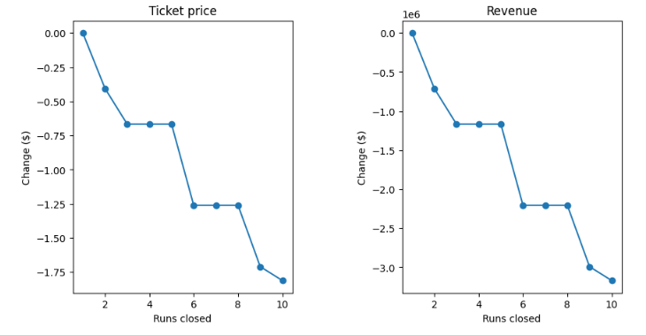

The adult weekend ticket price is $81. Currently, as one more chair is added, it's expected to increase support for the ticket price by around $0.30 and is expected to amount to $507246. Adding a run and increasing vertical drop is expected to increase profits even more, increasing ticket price by $2 and amounting to $3474638. Scenario 2 is recommended for more consideration due to it having the most significant change. To test out run closures, surveys can be conducted and usage data can start to be reported if it hasn't been already. Prices can also be adjusted accordingly due to fewer avenues of entertainment at the resort.

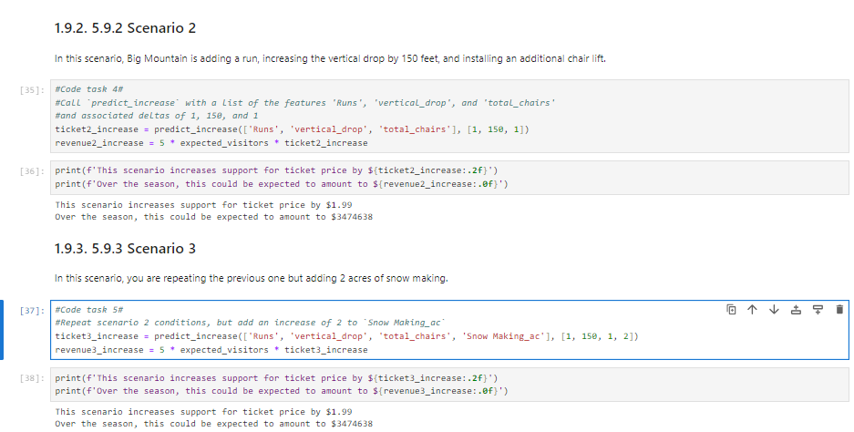

Operating expenses for staffing, marketing, and snowmaking, for example, could be helpful to analyze. The mean absolute error was around $10, which can explain the difference. A lot of missing data limited the amount of analysis that can be done, even with machine learning. This model can be used as is for business analysts, or a GUI can be made for it as well.